# User Manual

## Group-02

## How to access different pages using navigation bar function:

After reading a brief summary of what RefugEAP is, there is a button ‘About us’ which will redirect the user to the about us page to learn more.

Buttons which provide easy navigation around the site. Appropriately named as to not confuse the user. Just click on the button to be redirected to the selected page.

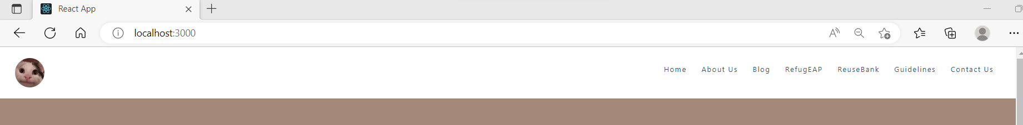

Every button engraved with hover effects to clearly notify user of their ideal page to visit.

Link to English provisions, specifically to https://www.displacedstudent.org.uk/

## Home page links:

Link to the RefugEAP reuse page where you can upload or view donations.

Link to the RefugEAP blog page where users can contribute their experiences.

## Social media integration through Twitter:

Twitter timeline embeds itself into the website, showing the latest tweets from the RefugEAP account, allowing the user to scroll through and interact with Twitter within the website. A button is also provided to automatically send the user to the RefugEAP twitter page and follow them, provided they are signed into Twitter, and giving them the option to sign in if they are not already.

## About us Page:

If you scroll down the aims of RefugEAP are displayed. You can navigate to the different aims by pressing the arrow buttons.

Heading is displayed for the user to see clearly, which helps with readability and accessibility, as the colours are not bright or too dark for the user to see.

At the bottom of the page is information displayed on the about us page for the user to read. The purpose of this page is to allow users to have a better understanding of what RefugEAP stands for. There is more information displayed below this, which the user scrolls down to for them to see.

## Contact Us Page:

RefugEAP contact page display screen. Short informative description informing Users that we would enjoy their suggestions and urging them to click the contact button form below.

Contact form button redirects Users to Google Form where they are urged to voice their suggestions, rate their current experience and leave their email to keep in touch.

Form is then submitted and sent to Account with an email affiliated with the website so we can filter through responses and respond or heed useful ones.

S s

## Blog:

Select ‘blog’ on the navigation bar to be redirected to the blog page.

This is what will first appear once redirected from the home page. If you press the ‘Contribute a blog’ button you will be taken to form page where you can submit a request to upload a blog.

This is the bottom of the blog page, where the blogs will be displayed once they have been created.

By pressing on these navigation buttons the user can access the next page of blogs and also return to the previous one. Each page is numbered for easy navigation.

This is the ‘Submit a blog’ form. The page provides guidelines and information for the users to follow on and know what they must fill in to submit a form.

Use the scrollbar to scroll to the bottom of the page to view the form.

Once you have filled in your information and completed the form, press the ‘Submit’ button where your form will be sent to be reviewed by an admin.

RefugEAP Page:

Select ‘RefugEAP’ on the navigation bar to be redirected to the blog page.

Select ‘LEARN MORE’ on the navigation bar to be redirected to an external website where there is more information about the programme

**Case Study**

This is the case study section for the EAP programme, where the articles will be displayed once they have been created.

Reuse bank:

These are items which have been put up for donation for the users to see.

Scroll bar to navigate to the list of items

Number of items.

Guidelines page:

The guideline page is a page dedicating to informing the user of the best practises when in regards to using the site and generally with the company. It provides comprehensive sets of advice detailing the best ways to connect with others, scale your impact or even tap into an inspiring vision.

Pop up text button to help the user navigate better.

Use the scrollbar to scroll to the bottom of the page to view the form.

Join Us:

On the join us page information on how to contact and join the RefugEAP organisation is displayed.

Users are given the option to sign up to their mailing list with an email.

Footer:

Navigates users to the ‘Contact Us’ page.

Navigates users to the organisations twitter.

Navigates users to the ‘Join Us’ page where they can sign up.